Guidance

COVID-19: support for businesses
Upd
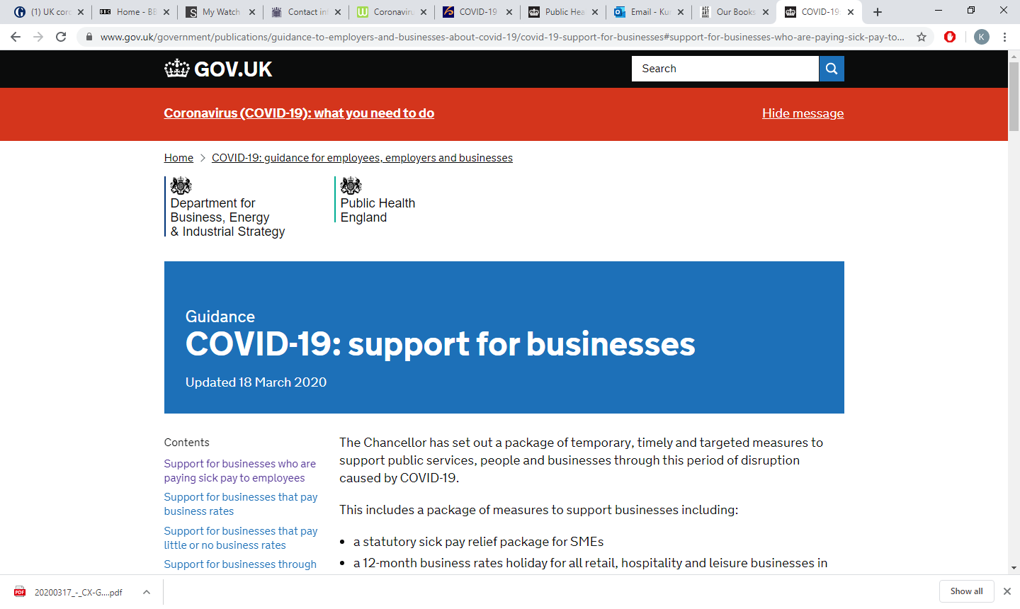ated 18 March 20202020

The Chancellor has set out a package of temporary, timely and targeted measures to support public services, people and businesses through this period of disruption caused by COVID-19.
This includes a package of measures to support businesses including:
- a statutory sick pay relief package for SMEs
- a 12-month business rates holiday for all retail, hospitality and leisure businesses in England
- small business grant funding of £10,000 for all business in receipt of small business rate relief or rural rate relief
- grant funding of £25,000 for retail, hospitality and leisure businesses with property with a rateable value between £15,000 and £51,000
- the Coronavirus Business Interruption Loan Scheme offering loans of up to £5 million for SMEs through the British Business Bank
- a new lending facility from the Bank of England to help support liquidity among larger firms, helping them bridge coronavirus disruption to their cash flows through loans
- the HMRC Time To Pay Scheme

Support for businesses who are paying sick pay to employees
We will bring forward legislation to allow small- and medium-sized businesses and employers to reclaim Statutory Sick Pay (SSP) paid for sickness absence due to COVID-19. The eligibility criteria for the scheme will be as follows:
- this refund will cover up to 2 weeks’ SSP per eligible employee who has been off work because of COVID-19
- employers with fewer than 250 employees will be eligible - the size of an employer will be determined by the number of people they employed as of 28 February 2020
- employers will be able to reclaim expenditure for any employee who has claimed SSP (according to the new eligibility criteria) as a result of COVID-19
- employers should maintain records of staff absences and payments of SSP, but employees will not need to provide a GP fit note
- eligible period for the scheme will commence the day after the regulations on the extension of Statutory Sick Pay to those staying at home comes into force
- the government will work with employers over the coming months to set up the repayment mechanism for employers as soon as possible

Support for businesses that pay business rates
We will introduce a business rates retail holiday for retail, hospitality and leisure businesses in England for the 2020 to 2021 tax year.
Businesses that received the retail discount in the 2019 to 2020 tax year will be rebilled by their local authority as soon as possible.
A £25,000 grant will be provided to retail, hospitality and leisure businesses operating from smaller premises, with a rateable value between £15,000 and £51,000.
Any enquiries on eligibility for, or provision of, the reliefs should be directed to the relevant local authority. Guidance for local authorities on the business rates holiday will be published by 20 March

Support for businesses that pay little or no business rates
The government will provide additional funding for local authorities to support small businesses that already pay little or no business rates because of small business rate relief (SBBR). This will provide a one-off grant of £10,000 to businesses currently eligible for SBRR or rural rate relief, to help meet their ongoing business costs.
If your business is eligible for SBRR or rural rate relief, you will be contacted by your local authority – you do not need to apply.
Funding for the scheme will be provided to local authorities by government in early April. Guidance for local authorities on the scheme will be provided shortly.

Support for businesses through the Coronavirus Business Interruption Loan Scheme
A new temporary Coronavirus Business Interruption Loan Scheme, delivered by the British Business Bank, will launch next week to support primarily small and medium sized businesses to access bank lending and overdrafts. The government will provide lenders with a guarantee of 80% on each loan (subject to a per-lender cap on claims) to give lenders further confidence in continuing to provide finance to SMEs. The government will not charge businesses or banks for this guarantee, and the Scheme will support loans of up to £5 million in value. Businesses can access the first 6 months of that finance interest free, as government will cover the first 6 months of interest payments. Further details, including on the lenders providing access to this scheme will be announced in the coming days, and the scheme will be available from early week commencing 23 March 2020.

Support for larger firms through the COVID-19 Corporate Financing Facility
To support larger firms, the Bank of England has announced a new lending facility to provide a quick and cost effective way to raise working capital via the purchase of short-term debt. This will support companies which are fundamentally strong, but have been affected by a short-term funding squeeze, enabling them to continue financing their short-term liabilities. It will also support corporate finance markets overall and ease the supply of credit to all firms. Further details, including on how to access this funding will follow in the coming days, and the scheme will be available from the week commencing 23 March.

Support for businesses paying tax
All businesses and self-employed people in financial distress, and with outstanding tax liabilities, may be eligible to receive support with their tax affairs through HMRC’s Time To Pay service. These arrangements are agreed on a case-by-case basis and are tailored to individual circumstances and liabilities.
If you are concerned about being able to pay your tax due to COVID-19, call HMRC’s dedicated helpline on 0800 0159 559.

Insurance
Businesses that have cover for both pandemics and government-ordered closure should be covered, as the government and insurance industry confirmed on 17 March 2020 that advice to avoid pubs, theatres etc is sufficient to make a claim.
Insurance policies differ significantly, so businesses are encouraged to check the terms and conditions of their specific policy and contact their providers. Most businesses are unlikely to be covered, as standard business interruption insurance policies are dependent on damage to property and will exclude pandemics.

